Report on SE Parent-Teacher Interaction Meet

Date and Time: Saturday 20/7/2019, 2:30-5.00 pm
Academic Year: 2019-20 Venue: Auditorium

Members Present:
Director - Bro. Jose Thurithiyil,
Dy. Director- Bro. Vijay Kumar Pereira
Principal - Dr. Sincy George,
HOD - Dr. Joanne Gomes
TPO - Mr. Wilson Pinto
Students, Parents, Teaching and Non-teaching staff of INFT department.
Ms. Shobha Tyagi compered the event.

Agenda:
- Registration and distribution of feedback forms (2:00 pm- 2:30 pm)
- Prayer
- Welcome speech by Director
- Address by Principal
- Talk by TPO
- Break for tea
- Department highlights by the HOD
- Talk by Dr. Nazneen, about Alumni committee and extra-curricular activities
- Parents interaction with SE class coordinators

The meet commenced with St. Francis prayer song. Director Rev. Bro Jose Thurithiyil gave the welcome speech. He spoke about role of Parents in child overall development. He thanked all the parents for taking time out from their busy schedule. Principal Dr. Sincy George explained need for PTI meeting and how much impact it has on overall development of the ward. Training and Placement Officer (TPO) Mr. Wilson Pinto then gave a short speech. He mentioned about placement activities in SFIT, Placement of 2019 batch, CGPA requirement for placements and technical skill development for students. The meet was then declared open for question answer session for parents. Parents asked queries with respect to placement and various other criteria. A short tea break was given followed by HOD Dr. Joanne Gomes presentation. Dr. Joanne Gomes gave a detailed presentation on activities of INFT department adhering to the vision and mission of college. It includes following points:
  - Objectives of Parents Teachers Interaction (PTI)
  - Vision and Mission of the Institute and Department
  - Academic Structure
  - Faculty and supporting staff and infrastructural details
  - R/D, library, Rad-lab, E-cell Facilities
  - Teaching Learning Process
  - Students Evaluation Pattern
  - Students activities
  - Institute & Department Activities
Followed by HOD presentation Dr. Nazneen Ansari gave short presentation about Alumni committee and extra-curricular activities. She spoke about our alumni across the globe and about various companies they are working and how this network can help the current students. The meet was concluded by introducing each staff member of the department, followed by vote of thanks.
The meet was then declared open for question answer session for parents. And further interaction with respective class coordinators.

Glimpse of PTI meeting

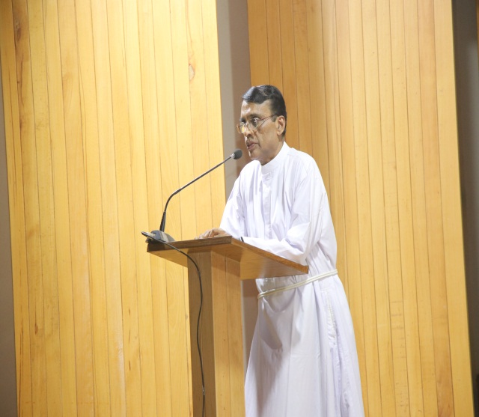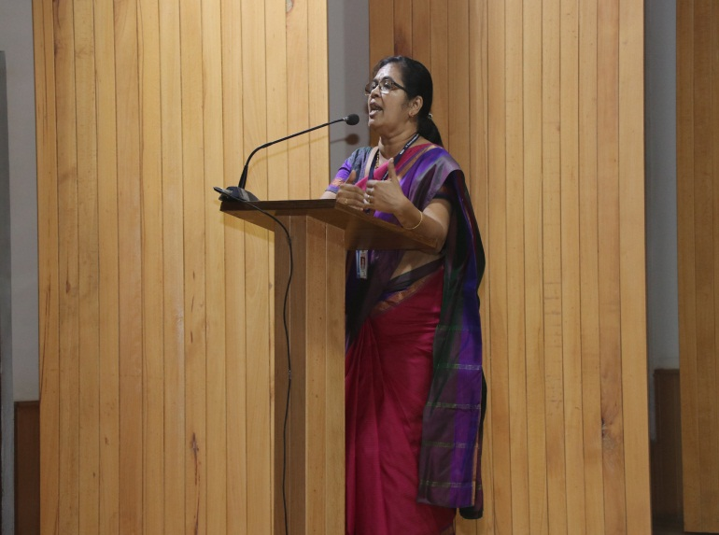

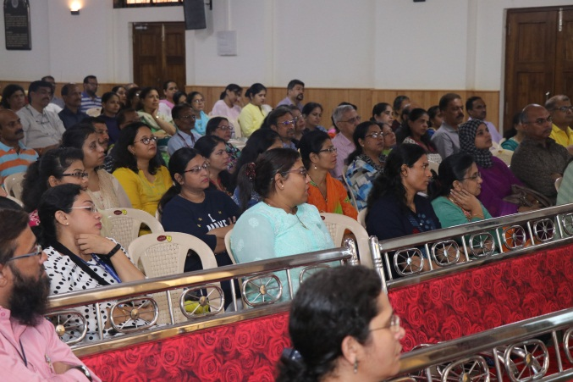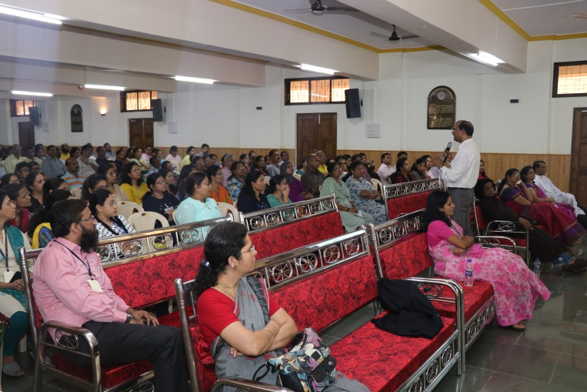

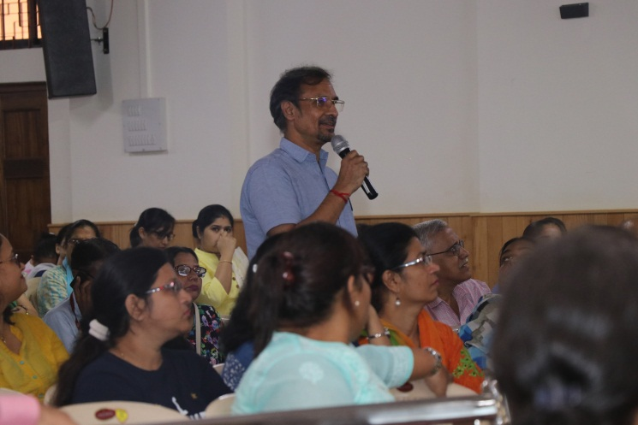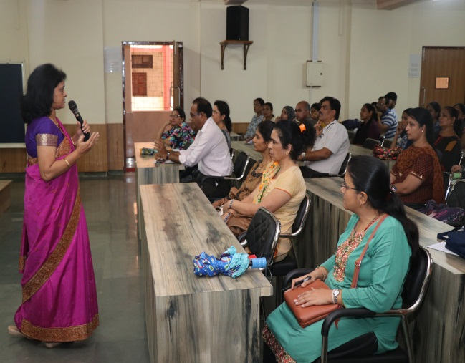

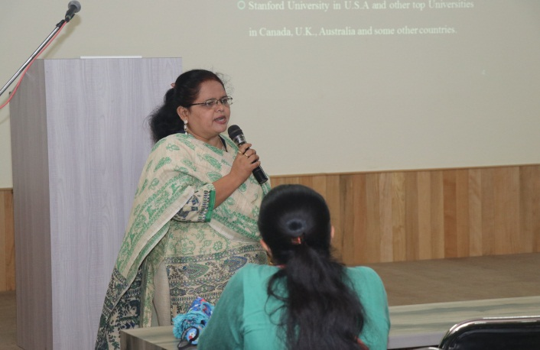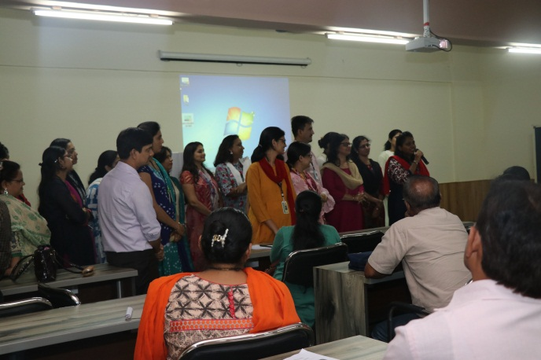

Prepared by Ms. Prajyoti Dsilva (INFT department)

